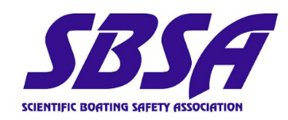
2025 Membership Meeting
November 18 – 20, 2025
Tuesday, November 18th (9:00am – 5:00pm)
Activity: SBSA Business Meeting
Location: CSUMB Alumni and Visitor Center Parking: Lot 97 South of Visitor Center (Pay to Park)
https://oregonstate.zoom.us/j/94149207278?pwd=nWqLmztibZVtrf5oKmcddaxheaaWwE.1
- 09:00 - Welcome & Introductions (Taylor Eaton)
- 10:00 - SBSA Membership Update (SBSA Board of Directors)
  - Welcome Zoomers and Membership Update
  - Elections (collect nominations)
  - Financial Report
  - Stats
  - Training Awards
  - Training Update

Link to Slides https://ucsb.box.com/s/jzc90zbuey5mamin01jlffl8cjsvn0fe
Link to eLearning updates: https://ucsb.box.com/s/xu9i8heytuj10kqcd3889mp2zzu6z2zq

Additional information can be found below in the minutes.
- Zoom participants:
  - Aaron Garcia, Adam Rok, Andrew Romanelli, Brian Caccioppoli, FAU Brian Bennett, Jason Jones, Jeff Anderson, Kevin Buch, Luke Robert, Reid Parker, Steve Evert Stockton University, Trever Traurig WDFW
- Membership (presented by Carly Haack): Total annual payments went from 28-55 paid memberships per year since 2020, to 73 paid memberships in 2025.
  - Currently $21k in account. We are planning to start putting more funds towards new initiatives, such as new training awards (announced later in the slides – Instructor Training Award & Program Development Award)
  - Update your organization’s email contacts/ add new members to the listserve through the OM application https://scientificboating.org/?page_id=861
  - Check if you’ve paid annual dues/ submitted stats here https://scientificboating.org/?page_id=8
  - Add us on LinkedIn https://www.linkedin.com/company/scientific-boating
- Elections (presented by Steve Clabuesch): We would love to see new people come into President; Secretary/ Treasurer; Membership Director roles. We encourage you to apply and join the board! Feel free to submit nominations via email to Steve Clabuesch srclabue@ucsc.edu
  - We will be providing SOPs for each position, so you’ll have a better idea of what the tasks include. This is a volunteer board, so many items are also based on your interest/ what Board initiatives you’d like to work towards during your term.
  - Nominations close Nov 27. The election period will run from Dec 1-22. Each OM is entitled to 2 votes, and each IM is entitled to 1 vote. New terms will begin Jan 1, 2026 and run through Dec 31, 2027.
- Awards (presented by Nathan Schwarck): Four Student Training awards ($500 each) recipients this year. Congratulations to the recipients! https://scientificboating.org/?page_id=1538
  - We have also added a *New* Instructor Training Award ($500 each) to help offset costs for instructor hands-on boat safety courses
    - We will be creating an application for the SBSA website.
- Statistics (presented by Taylor Eaton): We have had a large increase in stats submissions. Please submit your stats yearly. These stats are instrumental for painting a picture of the SBSA organization. The number of OMs reporting stats increased by 10% in 2024 and 20% in 2025. https://scientificboating.org/?page_id=1226
  - Q about paddlecraft guidelines. View SBSA website for paddlecraft guidelines compiled from SBSA and various institutions: https://scientificboating.org/?page_id=1522
  - If we could add one new metric to improve decision making, what would it be?
    - James Morioka PMDP Hawaii-
      - How many instructors are newly certified?
      - How many MOTC courses have been taught?
      - How many modules have been taught?
      - Accidents and near misses?
    - Mike Anghera SDSU/ UC Enterprise
      - What are people’s program budgets? Hourly rates? How much staff?
        - We could add a separate section to stats with more programmatic questions.
      - Having incident/ near miss added to stats
      - How much grant money/ research was supported?
    - Pete Loschl- How many of the boats were actively used this year vs how many were inactive?
    - Board- We’ve discussed editing the stats questionnaire, but balancing having people submit/ not making the submission process too long and onerous, but also getting as much data as possible.
      - Perhaps new Board can modify questionnaire/ Or a team can be created to work on this.
      - Or figure out how to get a wide range of groups to contribute stats. Could create separate tabs of a shorter/ basic survey and a longer one. Or divide up “do you have power boats, paddlecraft, staff, etc. clicking yes will have you answer those various sections. “No’s” will help limit length of survey.
    - Creating a team to generate a report of looking into the industry standard of scientific boating? Publish it somewhere with some metrics that are updated regularly enough?
- Training Updates (presented by Dan Battaglia): 2023 meeting discussion: Updating operational and training guidelines; defining and enacting policy regarding MOTC Instructor levels.
  - Previously, had defaulted to follow MOCC guidelines.
  - The largest number of feedback was on the MOTC standards (17 responses), and the lower numbers of feedback for specific modules.
    - Feedback included punctuation/ formatting; grammar; general “you should consider” comments; actionable suggestions of policy changes; clarifying questions
  - Have now created a final draft that is available on the website. https://scientificboating.org/?page_id=890
  - MOTC baseline requirements is still 24 hours, as aligns with DOI. Suggestion is to bring it to 32 hours (70% of participants believe 3 days is too short).
    - 4 days can cause increased instructor associated costs/ day in the field that may impact programs.
    - Document covers minimum guidelines of MOCC, so it will maintain reciprocity w DOI/ MOCC.
  - GAR requirements: They have kept GAR in the materials since it’s required by DOI for MOCC. GAR is a valuable planning and operational tool.
    - You can introduce additional tools in your program, but as of now GAR is still needed in instruction.
      - Future Goals: Workshop the GAR in future business meetings?
      - JD: Adding a GAR module into the eLearning? Could be a GAR specific quiz with scenarios written out and evaluated as teams?
      - Fabiola UBC: To her, GAR is more of a tool to use throughout the day, not just for risk analysis and the beginning of the day, but she wants it as a tool to continue to reevaluate throughout the day.
    - To do for membership: Ensure we’ve captured this in the policy document, as well as in the eLearning. We’d like the policy document to capture these things, while still not being “too-specific” that it limits programs.
      - Greg Flederman UCD: The GAR allows people to make risk assessments, no matter the experience the individual has in boating. Allows anyone to have a say in risk assessment and understanding.
      - James PMDP: Helps them with risk assessment/ liability by providing proof of risk assessment and hard number.
    - Dan’s has been wanting to run a risk analysis workshop next year to help show people how they can better use the GAR in their operations.
      - Proposal to formally adopt the document- we can still make additional edits in the future.
  - To do: develop a team to revise training materials and adopt standardized “branding” across printed materials, ppt, elearning, and website. Volunteers?
- Membership Updates (presented by Taylor Eaton): We have updated some of the SBSA bylaws. https://scientificboating.org/?page_id=890 Article IV S 4: Clarified number of votes OMs and IMs; Article V1 Section 2. Added ability for BoD to appoint directors to help w special projects- eLearning; Article V1 Section 4: Added requirement for past president to serve 1 additional year as support.
  - We are increasing dues from $80 annual cost to $150 annual cost. Individual membership will not increase, and will stay at $25.
  - Dues increase will support:
    - MOITC Awards ($500 2x/yr)
    - Program Development Award ($3000 max 1/yr) to develop MOTC capabilities at an active OM institution
      - To help support instructor traveling fees, program fees, etc. needed for organization’s to successfully hold boat safety training
      - These will be in place on the https://scientificboating.org/?page_id=1538
    - eLearning director position (to establish reliable IT support, enrollment updates, expansion)
- Online Merch Store- https://scientific-boating-safety.myspreadshop.com
  - Provide instructor’s with logo access for MOTC Instructor type apparel? Currently, we don’t want to put any Instructor apparel online to ensure access is limited.
  - Slight mark-up on items so SBSA will receive some apparel funds that will be put into student awards.
12:00 - Lunch (Catered by Otter Kitchens Catering)
https://oregonstate.zoom.us/j/94862328597?pwd=yIx8jmTQYOv03tDr6TrfBneBkTDHU9.1
12:30 - Tour of CSUMB Aquatic Center, Dive Locker and Boats (Nick Nechay)
14:00 – SBSA eLearning Platform Update (Carly Haack)
- Scientific boating eLearning platform is now available for OMs to enroll their student groups. Please view our website for additional information https://scientificboating.org/?page_id=2176
15:00 - Break
15:15 – MOTC Standards Discussion and Vote (Dan Battaglia)
- Group went through MOTC standards document and provided edits & suggestions https://scientificboating.org/?page_id=2176
- Goal to clarify some of the DOI standards, and make them more specific to MOTC.
16:45 - Closing Thoughts (Taylor Eaton)

Wednesday, November 19th (8:00am-5:00pm)
Activity: Towing and Rendering Assistance Workshop
Location: Breakwater/San Carlos Beach Boat Ramp (Monterey, CA) (Pay to Park)
- 08:00 – Meetup and Briefing
- 08:15 – Field Lecture
- 09:30 – On Water Rotation 1
- 12:00 - Lunch (bring your own/breakwater has some restaurants)
- 13:00 – On water Rotation 2
- 15:30 - Vessel Recovery and Washdown
- 16:30 – Debrief, and Group Photo!

Thursday, November 20th (9:00am – 5:00pm)
Activity: SBSA Membership Discussion and MBA Tour
Location: CSUMB Alumni and Visitor Center
https://oregonstate.zoom.us/j/98239028549?pwd=k3GYarw4Y1QETKey1RhIHP8AiQGmMB.1
- 09:00 - Welcome
- 09:30 – USCG Presentation (H. Taylor)
- 10:30 – Break
- 11:15 – Discussion with USCG Rep (Fitzgerald/Monk)
- 12:00 - Lunch (Catered by Otter Kitchens Catering)
- 12:30 - Travel to the Monterey Bay Aquarium
Location: Monterey Bay Aquarium Parking: Canary Row Parking Garage, limited parking available near aquarium. (Pay to Park)
- 13:00 - Boat launch Demonstration (Andrew Morgan)
- 14:30 - Monterey Bay Aquarium Tour (Andrew Morgan)
- 16:45 - Closing Thoughts, Farewells and Group Photo! (Taylor Eaton)
Registration Fee: $200 /person for all three days, space is limited. Please register at: https://docs.google.com/forms/d/e/1FAIpQLScVpJRUeXCeEph5SK1R57ZbPj-xvun6po8Y6lDUyXNYWzRWRA/viewform?usp=dialog Registration closes on 10/31/2025.

Directions: CSUMB Alumni & Visitors Center - Map
Alumni and Visitors Center
Physical: 5108 Fourth Ave, Marina, CA 93933
Mailing: 100 Campus St, Seaside, CA 93955
Recommended parking in Lot 97 just south of the Visitors Center (pay to park).
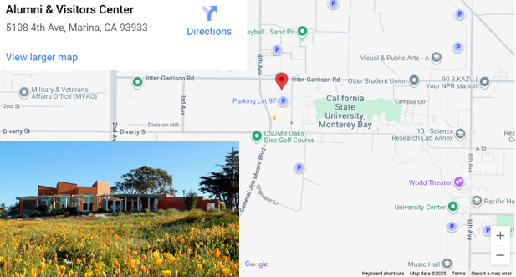
Lodging Recommendations:
Spring Hill Suites – Hotel Near CSUMB Campus
Home2Suites by Hilton - Hotel Near CSUMB Campus
Other Lodging options exit nearby in Marina or Monterey, CA. CSUMB does not have on campus lodging available for outside guests during this time.
Food:
Morning coffee and snacks will be provided on Tuesday and Thursday.
A catered lunch by Otter Kitchens Catering available on Tuesday and Thursday.
Tuesday: Sandwiches and Salad
Thursday: Pizza
Professional Development Workshop: Towing and Rendering Assistance
This hands-on workshop is designed to strengthen your skills in towing and providing assistance from small boats in open water conditions. The training covers safe towing techniques, including stern tow and side tows, approaches, assisting disabled vessels, and effective communication during rescue scenarios. Participants will gain practical experience in risk assessment, coordination, and critical life-saving procedures. Whether you're learning new techniques or sharpening existing ones, this workshop offers a valuable opportunity for professional growth in a dynamic, team-based environment.
Bring your own working lunch, drinks and snacks. Bring working clothes suitable for on water portions of the class.

Alternative Activities in the Area:
- Monterey Bay Aquarium – world class aquarium and research center
- Fisherman’s Wharf – pier, restaurants, shopping, whale watching tours
- Point Lobos State Reserve – sight Seeing, Whalers Cove, hiking
- Fast Raft Ocean Safaris – whale watching
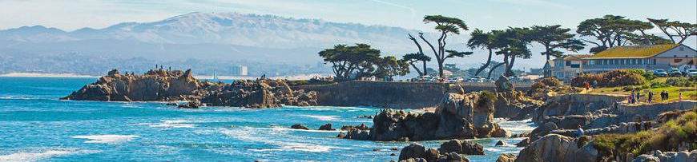
https://scientificboating.org/

