Summer Session: Aquatic Safety Guidelines
Purpose: To ensure all visiting students are properly advised of the aquatic hazards while visiting Bodega Marine Laboratory and oriented for safely exploring the adjacent waterways along the north coast, bays, harbors and rivers.
Background: Each year many visitors travel here to explore the Northern Coast of California and every year, right here in the Bodega Bay and Russian River areas there are numerous COLD WATER related accidents that result in severe injuries and fatalities. These incidents are directly attributed to not understanding the hazards, poor preparation, a lack of training and experience and a loss of situational awareness. We want to help you manage the risks!
Class Research Projects: If your class project involves activities that will require you to be working; in, on, or over the water for any field work, you will need specific authorization from your class advisor; and you must attend the appropriate BML safety orientation and skills assessment.
- Any class work involving outdoor water hazards requires that you always “Use the Buddy System.”
If YOU don’t know or are alone; don’t take the chance, DON’T GO!
Water Safety Facts: You must constantly be aware of your resources and surroundings!
- To be effective, Life Jackets and Personal Floatation Devices (PFD’S) must be worn when working in or over water.
- Most drowning victims are within 10 feet from safety.
- Cold water immersion can cause drowning in less than 1 minute.
- Waves and water currents can overpower and overwhelm trained professional athletes.
Always Wear a Life Jacket!
Cold Water Immersion and Survival: Use the “1-10-1 Rule” if immersed in cold water; DON’T PANIC
- 1 Minute to get your breathing under control
- 10 Minutes of meaningful movement for a survival strategy
- 1 Hour of survival before Extreme Hypothermia takes effect
Always leave a copy of your Field or Float Plan with a responsible person!
Field Plans and Float Plans: Let someone know; it can inform rescue personnel where to search if you do not return!
- Time of departure and when you should be returning.
- Type(s) of transportation and location(s) of activities and routes taken.
- Emergency Contact persons and numbers
- Any special information or health considerations.
Local EMERGENCY #’s: 911 / Sheriff- 707-565-2121 / Bodega Bay Fire- 707-875-3002 / USCG 707-875-3596
Bodega Marine Laboratory #’s: BML Office-707-875-2211 / ARG-875-1978 / Housing- 875-3702

Beach and Intertidal Hazards:
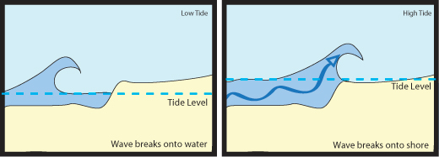
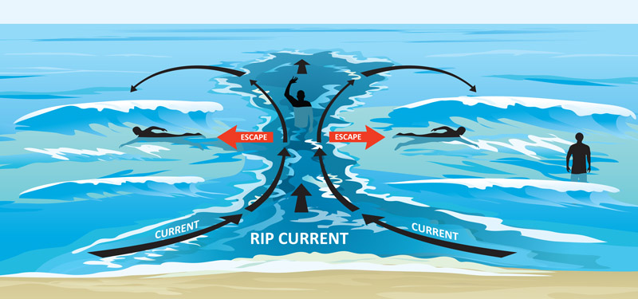
River Hazards:
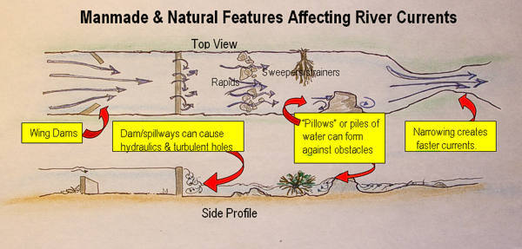
Safety Requirements for Student Aquatic Field Research Activities

Student Name:________________________ Project Activity:______________________
Field Location:________________________ Project Field Dates:___________________
Project summary and field activities description: ____________________________________________________________________________________________________________________________________________________________________________________________________________________________________________________________________________________________________________________
Field Activity Hazards Orientation and Safety Assessment:
(Must be pre-arranged by your class advisor to schedule a specific appointment for your group)
- Intertidal (Seining and Wading) Date/Time:________________
- Sub-tidal (Snorkeling, Swimming Freediving) Date/Time:________________
- Boating (Kayaking, Rafting, Floating) Date/Time:________________
Personal Responsibilities: Protective Clothing, Field Planning and Risk Management
- I must be able to properly outfit myself for the aquatic activity.
- I must be able to safely transport myself and equipment to the field location.
- I must File a Field/Float Plan for each date of the activity and Close it when I return.
- I will always take a “Buddy” for each field outing.
- I understand that outer bay and offshore kayaking is prohibited by BML policy.
Student Acknowledgement:_____________________________ Date:____________________
Approvals: (Activity must be approved by the class advisor and appropriate department.)
- Class Advisor: ________________________ Name/Email:_______________________
- Field Instructor:_______________________ Name/Email: _______________________
- Marine Operations:____________________ David Dann: dadann@ucdavis.edu
- Aquatic Resources Group: ______________ Karl Menard: klmenard@ucdavis.edu
- Diving Safety Officer: __________________ Jason Herum: jsherum@ucdavis.edu
- Boating Safety Officer: _________________ James Fitzgerald: jjfitzgerald@ucdavis.edu

